Contents
Introduction 0
Data Preparation 1
Descriptive Analysis 2
Analysis & Insights 3
Correlation and Outlier Analysis 4
Conclusion and Recommendations 5
References 6
Appendix 7
Appendix A – Reflection on the use of Artificial Intelligence 7

Introduction

The purpose of this study was to investigate holiday trends and traveller behaviour. As the summer period was just ending, I thought it would be a valid time to complete a survey. With today’s cost of living issues, I wanted to gauge if people are still willing to take summer holidays and get an understanding of the overall costs involved.
As part of the survey, I wanted to find out if people are still going overseas or preferring to stay in Ireland. Or areas of the survey were to look at the age range of respondents to get an understanding of how they book holidays and how much on average the holiday costs (overall and accommodation costs).

The survey was designed with Google Forms and called:
Recent Holiday Trends and Traveller Behaviour Survey

A link to the survey was issued to friends, family and fellow students on my Phone contacts. Everyone was notified that this survey was for academic purposes only and all responses will be anonymised.
“Thank you for taking part in this survey.
The purpose of this survey is to explore recent holiday trends and traveller behaviour. This survey forms part of an academic project for the Statistical Techniques for Data Analytics module.
The survey should take approximately 2-3 minutes to complete.
No personal identifying information is collected. All responses will be anonymised and used solely for statistical analysis and academic purposes.
Participation is voluntary and all information collected will be treated confidentially.
By completing this survey, you consent to the use of your anonymised responses for academic analysis.”
A total of 66 responses were received, and the dataset was downloaded as a csv named:
Data_CA1.csv

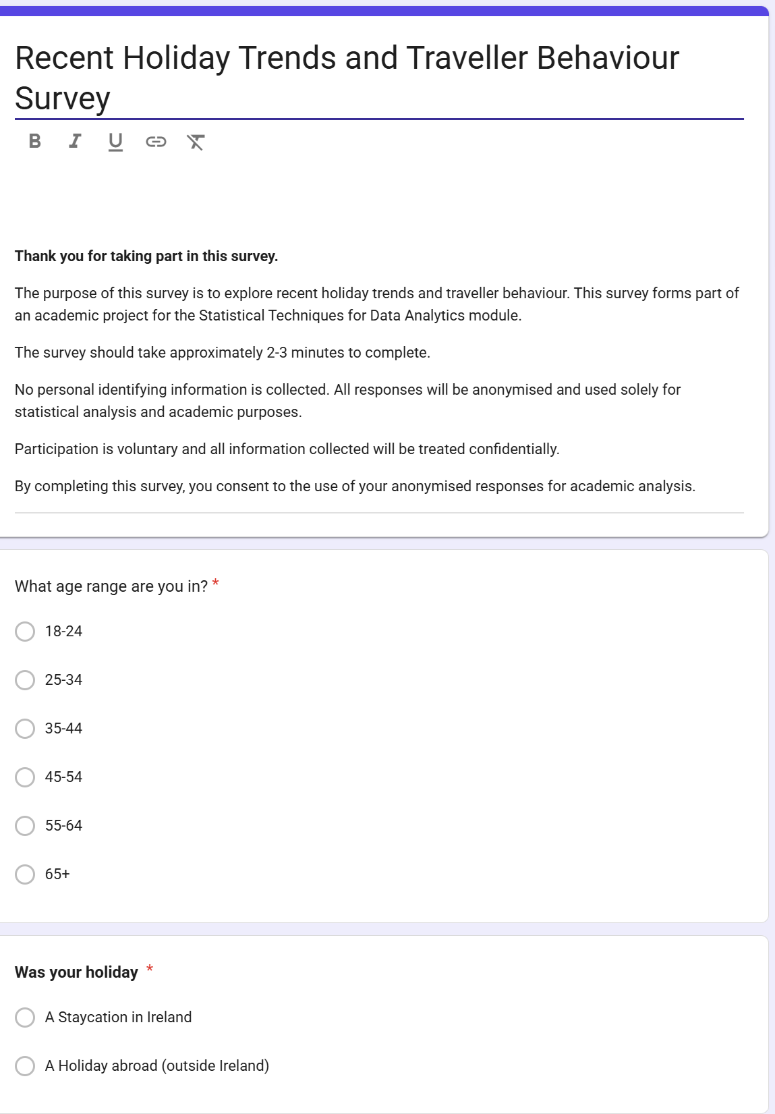

Data Preparation

The questions were designed in a way to give us data on:
Categorical Variables
- Holiday Location (Home or Abroad)
- Booking Method (Online or Package)
- Holiday Purpose (Beach Holiday or City break, etc)
- Holiday Recency
- Age Range

Numerical Variables
- Holiday Length
- Overall Holiday Cost
- Accommodation Cost
- Group Size
- Number of Holidays in last 12 Months

Likert Scale
- Satisfaction Rating

Boolean Variables
- Would you take this type of Holiday again
- Did you travel by air

Descriptive Analysis

Analysis & Insights

Correlation and Outlier Analysis

Conclusion and Recommendations

References

CCT College Dublin (2026) Statistical Techniques for Data Analysis Module Notes. Available via Moodle
CCT College Dublin (2026) Data Preparation Module Notes. Available via Moodle
Microsoft 365 Copilot. Use for statistical concept explanations, Python debugging, report structuring and analytical support,
Udemy (2026) Python for Machine Learning & Data Science Masterclass. Available at: Udemy
Zero To Mastery (2026) Complete A.I. Machine Learning and Data Science: Zero to Mastery. Available at: Zero To Mastery

Appendix

Appendix A – Reflection on the use of Artificial Intelligence

Artificial Intelligence (Microsoft 365 Copilot) was used throughout this project as a support tool to assist with understanding statistical concepts, Python programming, report planning and guidance in developing Google Forms. AI was primarily used to help explain correlation analysis, boxplots and outlier detection, although I have previous experience with these, whilst studying my Level 7 in Data Technology.
AI was also used to provide guidance when debugging code errors in Python, such as plotting visualisations, correlation matrices and pivot tables. In addition, AI provided suggestions on how to structure the reporting and improve the organisation of Jupyter Notebook.
A major benefit of AI was the ability to explain concepts and provide examples that could be adapted to my survey dataset. AI also helped identify areas where additional analysis was required, such as correlation analysis and outlier investigation.
However, all survey data was collected and analysed independently. The final decisions regarding the choice of statistical techniques, interpretation of results and conclusions remained my own responsibility.
Overall, the use of AI enhanced my learning experience by acting as a study aid and technical assistant, improving both my understanding of statistical techniques and my confidence in applying Python for data analysis.
AI was also used to review draft interpretations and suggest alternative wording for statistical findings. These suggestions were reviewed critically before being incorporated into the final report

